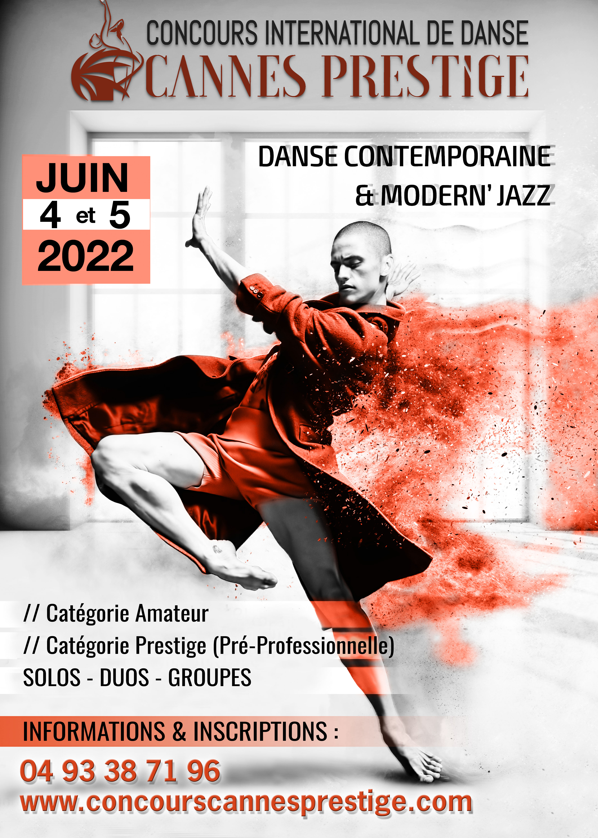

Contest Rules

The Cannes Prestige International Dance Competition is created to allow amateur dancers, or pre-professionals to evaluate their technical and artistic level.
It is open to dancers from 9 years old on January 1st of the year of the contest.

DATE AND PLACE OF THE COMPETITION
The competition will take place on Saturday 4th and Sunday 5th June 2022 at scène 55 :
55 chemin de Faissole, 06250 Cannes-Mougin.

PUBLIC RATES
Adultes
PASS 1 day 25€ PASS 2 days 45€

Childrens (- de 12 ans)
PASS 1 day 15€ PASS 2 days 25€

PASS FOR TEACHER (to be paid when registering the candidate (s)): 20€ (for 2 DAYS)
Access to the theater is free for contestants.

CONDITIONS OF REGISTRATION

Registration will be effective upon receipt of the complete file

Attachments:
Photocopy of the applicant's identity document, passport or family record
The registration form (1 newsletter per passage)
The registration check payable to S.N.C
Parental Certificate for Minor Applicants
Image rights

Only complete applications received before the registration deadline will be considered.
The convocations will be sent at the latest 15 days before the date of the contest.

The contest organizers reserve the right to close the entries before the deadline, if the contest is over, and to modify their progress.

Each candidate will have the opportunity to present 3 solo and group duets in each of the disciplines proposed in contemporary and modern dance.

REGISTRATION RATES :
Solo : 65€ for 1 disciplined
90€ for 2 disciplined

Duo : 40€ per dancers (80 € for the duet)

Groups : 28€ per dancers
CATEGORIES AND TIMINGS
SOLOS
CATÉGORIES | AGES | TIMING
Élémentaire 1 | 9 to 11 Years | 1min30 (maximum)
Élémentaire 2 | 12 to 14 Years | 2min (maximum)
Supérieur 1 | 15 to 17 Years | 2min (maximum)
Supérieur 2 | 18 et + | 2min (maximum)
Prestige (Pré Pro) | From 14 years old | 2min30 (maximum)

DUOS

CATÉGORIES | ÂGES | TIMING
Supérieur 1 | 14 to 16 Years | 2min30 (maximum)
Supérieur 2 | 16 and + | 2min30 (maximum)
Prestige (Pré Pro) | From 14 years old | 2min30 (maximum)
GROUPS

CATÉGORIES | AVERAGE OF AGE | TIMING
Élémentaire 1 | 9 to 11 Years | 2min30 (maximum)
Élémentaire 2 | 12 to 14 Years | 3min (maximum)
Supérieur 1 | 15 to 17 Years | 3min (maximum)
Supérieur 2 | 18 years et + | 3min (maximum)
Prestige (Pré Pro) | À From 14 years old | 3min30 (maximum)
An age waiver may be granted for a member of a group one year younger or older than the age required for the category.

RATING CRITERIA

The dancers will be penalized in case of non-respect of the durations imposed.
Dancers appearing to have excellent technique and registered in amateur category, may be penalized and reclassified.
The notation of the participants will be based on the choreographic work, the artistic quality of the dancer as well as his dance technique according to his category.

Competitors are free to greet their Audience and Jury Members.
The applause will be at the end of the category in order to not influence the jury.

WEAR AND ACCESSORIES
Outfits are free (costumes or simple dancewear).
Accessories and sets are allowed only if the dancers themselves put them in place and remove them from the stage. (The time of installation and uninstallation is counted on the passage time).
Objects that degrade the stage for the following passages are strictly forbidden and may penalize the dancers (talc, water, feathers, rosin, ...).

AWARDS

All candidates will be called on stage and will receive according to their ranking a diploma, a medal, a cup or a trophy (with scholarships, internships, winnings and exclusive rewards awarded by the Prestige Contest)
For the awards ceremony candidates must appear on stage in costume only.

19: Gold Medal and Grand Jury Prize with congratulations
18: Gold medal with congratulations from the jury
17: Gold medal unanimously of the jury
16: 1st prize Gold Medal
15: Silver Medal
14: Bronze Medal

MUSIC :
The music of each candidate will have to be sent on the following email:concourscannesdanseprestige@gmail.com (either by mail or we transfer)
Please specify in your email the NAME, FIRST NAME, CATEGORY, DISCIPLINE and TITLES of the choreography. The candidate will have to be in possession of a copy of his music on CD or USB key the day of the competition

JURY

The jury will be composed of 5 recognized personalities from the world of dance : Monique LOUDIÈRES, Marjorie ASCIONE, Roberta FONTANA, Carl PORTAL and Sadok KECHANA.

Monique LOUDIÈRES
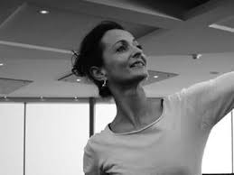

Star dancer of the Paris Opera.
She dances for Rudolf NOUREEV in a sequel she is named Star Dancer by Madame Rosella HIGHTOWER in 1982.
From 2001 to 2008 she was artistic director of the Rosella Hightower International school.

Marjorie ASCIONE
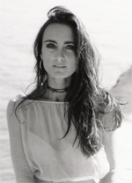
Artistic Director of the show «La France à un Incroyable Talent»
Choreographer for the musical Flashdance.
Choreographer of the show «MUGLER FOLLIES» by fashion designer Thierry MUGLER

Roberta FONTANA

Italian choreographer and teacher
Participant in numerous international internships and competitions

Hervé KOUBI

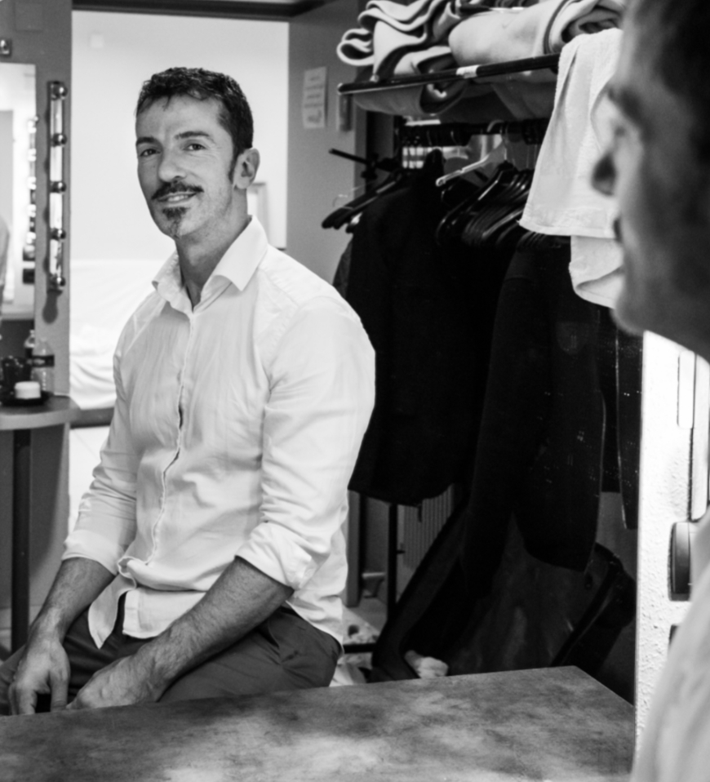

Dancer at the National Choreographic Center of Nantes Claude Brumachon and Benjamin Lamarche then at the National Choreographic Center of Caen with Karine Saporta ; and the Thor Company in Brussels with Thierry Smits , he created in 2000 his choreographic project .

Sadok KHECHANA
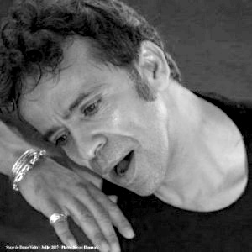
Teacher and trainer at the State Teacher Diploma
Dancer in the Company Matt MATTOX
Artistic director of the MSBK training school

VIDEO PHOTO CAPTURE

Photos and video capture will be provided by the company « Sud Reportage ».
Shooting, videos and photos are strictly prohibited.

TERMS OF PARTICIPATION

- Parental authorization is mandatory for minor candidates
- The organisers shall not be liable for any material or moral damage caused or suffered by the candidates during their participation in the competition.
- Organizers reserve the right to exclude a candidate in the event of force majeure.
- The organization reserves the right to modify the conduct of the competition.
- Only persons with a summons or a Teacher Pass will be allowed to enter the lodge.

ATTESTATION FOR MINOR

I the undersigned……………………………………………………………………………………………

authorize :

My children ……………………………………………………………………………………………………….
To participate in the Cannes Prestige International Dance Competition which takes place on Saturday 4 and Sunday 5 June 2022 at the 55 scene.
The organization of the contest, to disseminate the photos and videos taken during the contest on the Internet and/or in the press.
My child’s teacher(s) to make decisions regarding his or her enrolment.
The organisers, in the event of an accident, involve persons authorised for all medical care.

I hereby declare that:

That my child has no contraindications to the practice of dance
That my child’s vaccines are up to date
Have read and accepted the contest rules.

At …………………………..

Date…………………………..

Signature :

AUTHORIZATION TO SHOOT AND DISSEMINATE IMAGES

Je soussigné :
Family Name, Surname : ..............................................................................................
adress : .................................................................................................
Accorde à la société SUD REPORTAGE take photos and videos
on the occasion of:

Event Title: Concours International de Danse Cannes Prestige
Date of event: JUNE 4 and 5 , 2022
We grant the organisation of the Cannes Prestige International Dance Competition the right to broadcast images of any kind (Internet, social networks, local).
These provisions are brought to our attention in the context of the application of the legislation on respect for the right to image and respect for privacy.

Done at .............................. The ........................

Signature of legal representatives
Precede signatures with “Read and Approved”

